**1. In the below elements which of them are values or an expression? eg:- values can be integer or string and expressions will be mathematical operators.**

* -> expression (mathematical operators)

'hello' -> values (string)

-87.8 -> values (string)

- -> expression (mathematical operators)

/ -> expression (mathematical operators)

* -> expression (mathematical operators)

6 -> values (string)

**2. What is the difference between string and variable?**

Variable is an identifier, that is created and stored in a memory location. A variable can be of several types like integer, string, float, etc. based on the value we assign to it.

Anything we assign to a variable using single or double quotes, will be considered as a string. Thus, a string is one of several types of a variable.

**3. Describe three different data types.**

Integer

Float

String

Boolean

**4. What is an expression made up of? What do all expressions do?**

Expression is made up of values, containers, and mathematical operators.

e.g A = 1 + 4

Expressions are used to evaluate the values or represent the result on the screen.

**5. This assignment statements, like spam = 10. What is the difference between an expression and a statement?**

Expression is made up of values, containers, and mathematical operators while statement is just like a command that a interpreter executes.

**6. After running the following code, what does the variable bacon contain?**

**bacon = 22**

**bacon + 1**

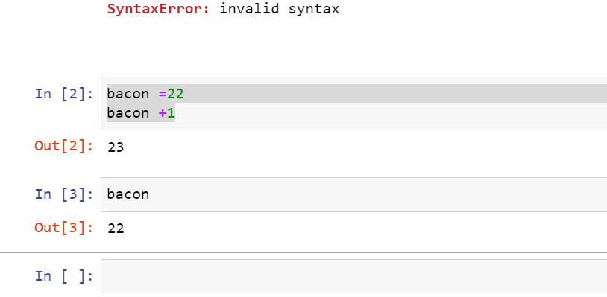

**7. What should the values of the following two terms be?**

**'spam' + 'spamspam'**

**'spam' * 3**

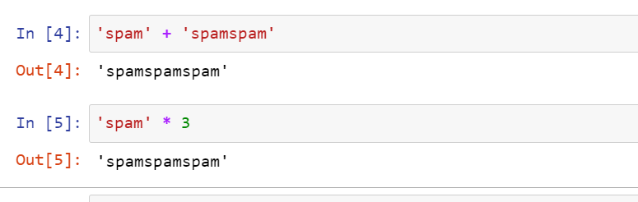

8. **Why is eggs a valid variable name while 100 is invalid?**

We cannot give any integer value for variable name, so 100 is invalid. But variable name can be an alphabet or string or start from an alphabet followed by integer value. Eg a, name, a1 etc.

**9. What three functions can be used to get the integer, floating-point number, or string version of a value?**

str(), int(), float()

**10. Why does this expression cause an error? How can you fix it?**

**'I have eaten ' + 99 + ' burritos.'**

99 is not a string so concatenate function will not work here.

**TypeError**: can only concatenate str (not "int") to str

To fix this, we need to write 99 also in single or double quotes, as mentioned below.

